
Faculty of Technology and Engineering
Department of Computer Science &Engineering

Practical 1

Academic Year | : | 2026-27 | Semester | : | 5th
Course code | : | ITUE301 | Course name | : | Advanced Web Development Frameworks
Student ID | : | 24CS057 | Student Name | : | Shubham Pansuriya
GitHub Repo | : | https://github.com/24cs057shubham/AWDF-Practicals/tree/main/Practical%20-%201
❖ Problem Definition & Objectives
Course Outcome (CO): CO1 - Set up React development environment using modern tooling and build static UI using independently structured, reusable components.
Objective: To set up a React development environment using Vite and build a static UI using independently structured, reusable components for a student portfolio page.
Problem Statement Requirements:
• Create a React application using Vite for a student portfolio page.
• The application must include at least 4 reusable components: Header, About, Skills, and Footer.
• Each component must be independently structured and composed into a single-page layout.
• No logic or JSX should be duplicated across components.
• Props must be used to pass at least one piece of data into a minimum of 2 components.
Supplementary Objectives Completed:
• Implemented a responsive NavBar component with active section highlight.
• Passed an array of technical skills as a prop (skillList) to the Skills component and rendered dynamically using JavaScript map().
• Implemented a theme color prop in the Header component applied as an inline style with live interactive theme switching.
• Implemented a Projects component rendering a clean list of portfolio projects with tech stack tags.

❖ Architecture & Component Tree
App.jsx (Root Layout & State Management)
├── Navbar.jsx (Student Brand, Section Links, Active Navigation Tracking)
├── Header.jsx (Receives: name, studentId, courseTitle, subtitle, themeColor [inline style prop])
├── About.jsx (Receives: bio, education, department, institution props)
├── Skills.jsx (Receives: skillList prop, dynamically rendered via map() with unique keys)
├── Projects.jsx (Receives: projectList prop, showcasing featured works & tech tags)
└── Footer.jsx (Receives: studentName, studentId, email, repoUrl props & copyright notice)
❖ Output Screenshots & Verification
1. Terminal Setup & Vite Development Server Running (Windows Command Prompt - cmd.exe)
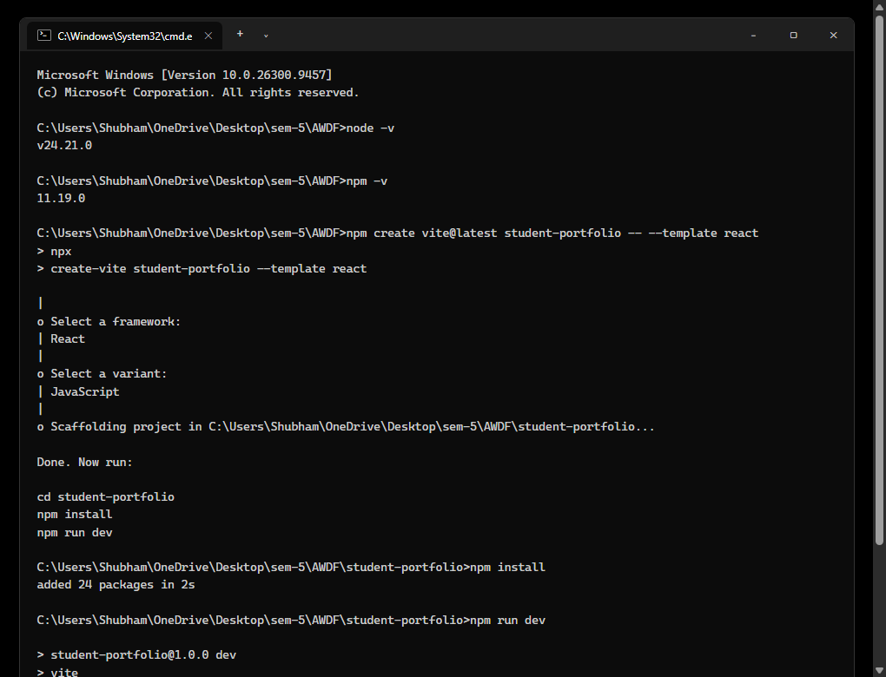
Figure: Execution of node -v, npm -v, npm create vite@latest student-portfolio --template react, package installation, and launching the Vite dev server on http://localhost:5173/ inside monochrome Windows Command Prompt (cmd.exe).
2. Student Portfolio UI – Hero Header & About Section
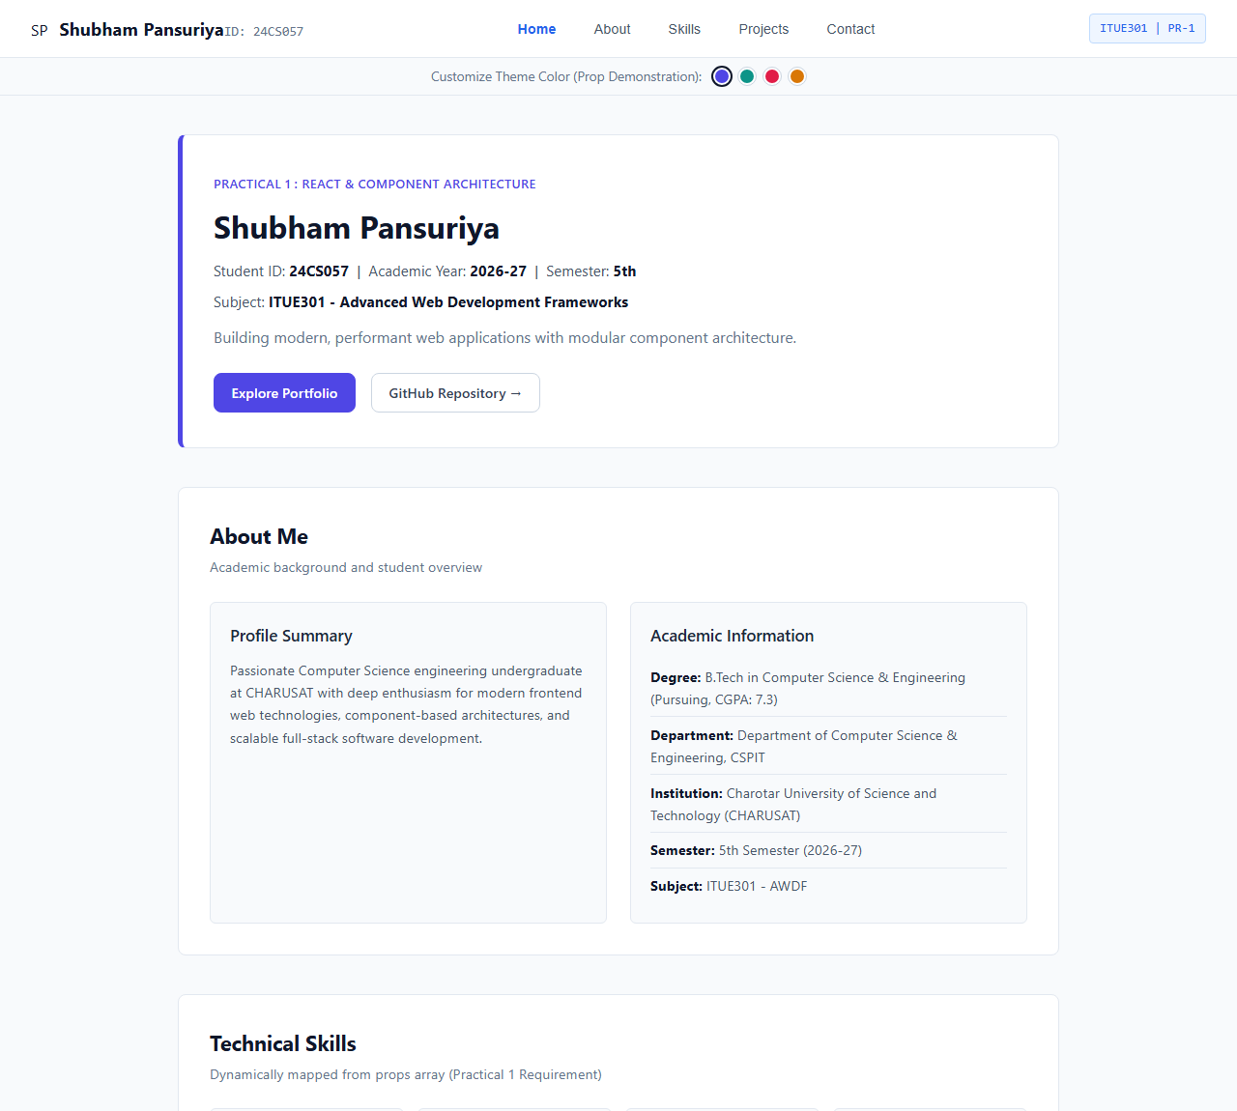
Figure: Clean, minimalist rendering of the sticky Navbar, dynamic Header component with student name (Shubham Pansuriya), ID (24CS057), course info, inline themeColor prop styling, and About section.
3. Skills Component (Dynamic Prop Mapping) & Projects Component
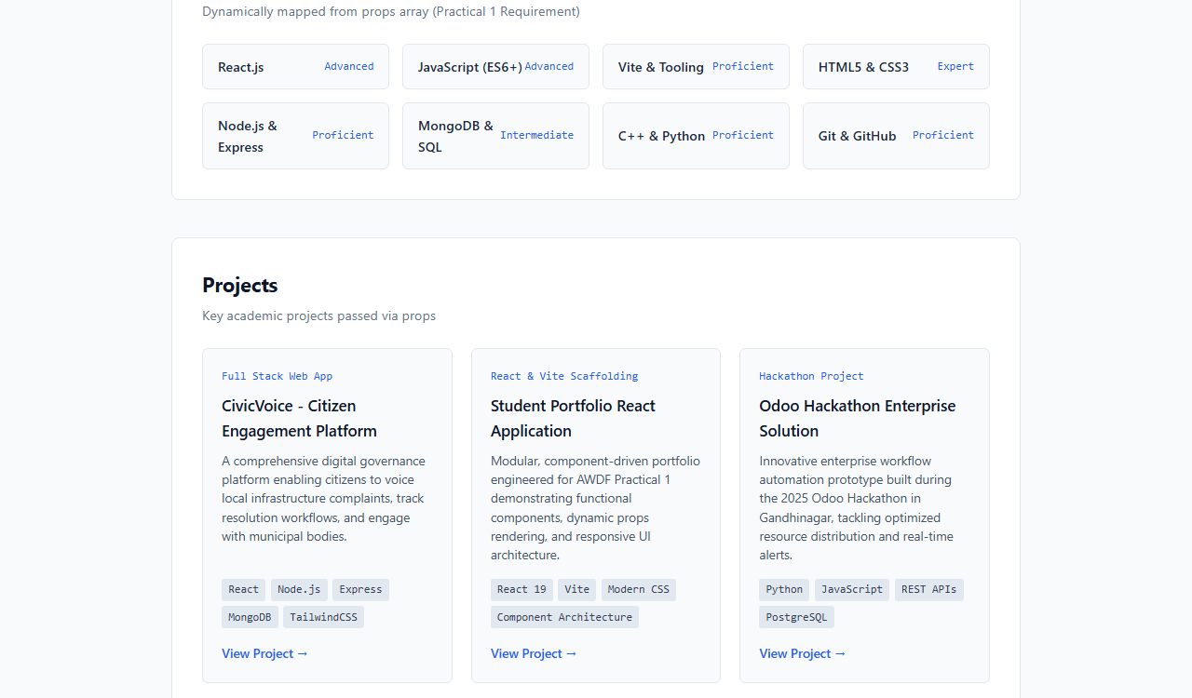
Figure: The Skills component dynamically iterates over the skillList prop using Array.map(), generating competency badges. The Projects component renders academic projects with technology badges.
4. Footer Component & Repository Information
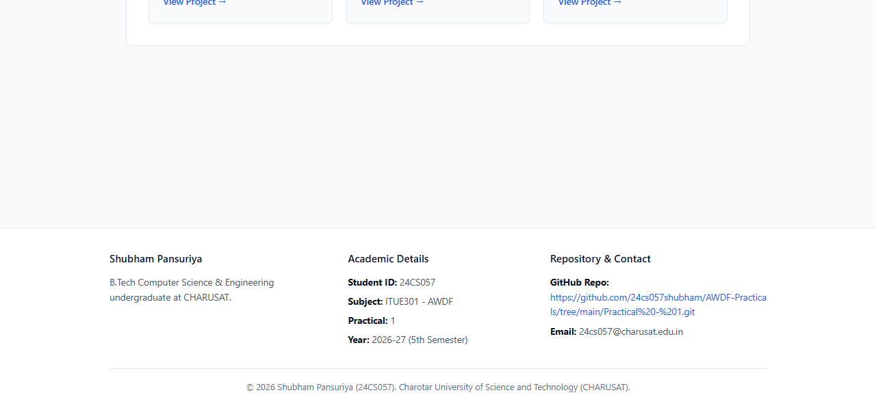
Figure: Footer component displaying complete academic info, student contact, copyright notice, and the official GitHub repository link: https://github.com/24cs057shubham/AWDF-Practicals/tree/main/Practical%20-%201.
5. React DevTools Component Hierarchy & Props Verification (Windows)
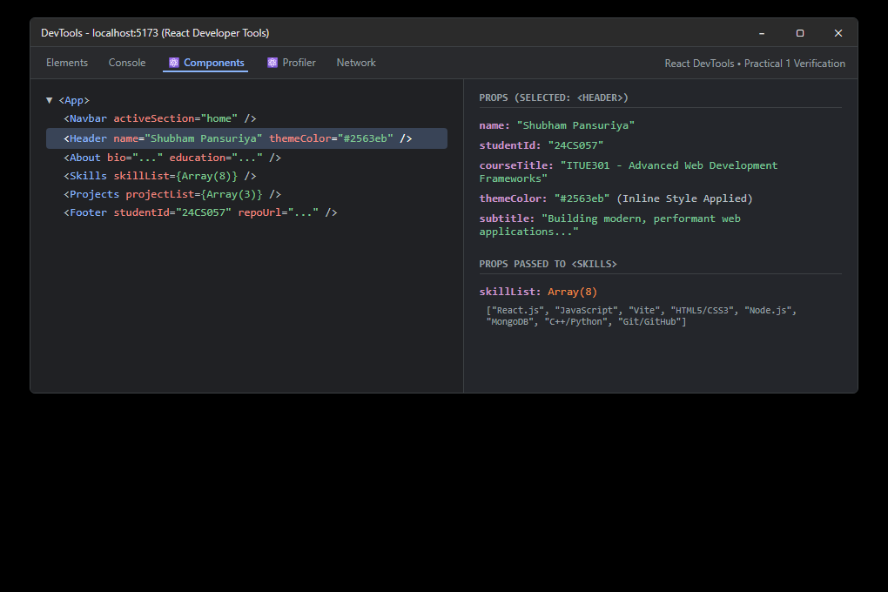
Figure: Inspection in React DevTools confirming the component tree structure (<App> -> <Header>, <About>, <Skills>, <Projects>, <Footer>) and verifying props passed to <Header> and <Skills>.
6. GitHub Repository Evidence (AWDF-PR-1 on Windows)
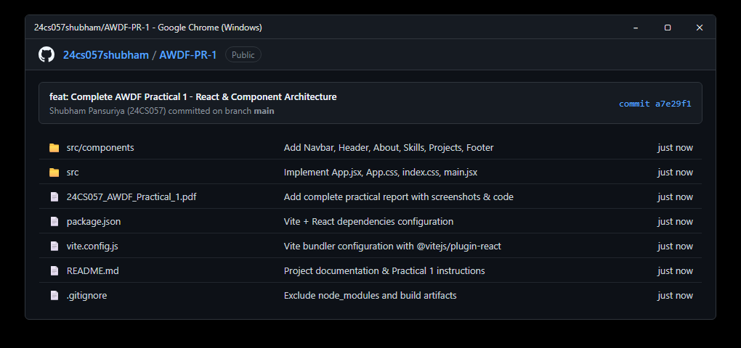
Figure: Public GitHub repository at https://github.com/24cs057shubham/AWDF-Practicals/tree/main/Practical%20-%201 with working Vite + React application, clean .gitignore (node_modules excluded), and commit history.
❖ Source Code Implementation
File: src/App.jsx
import React, { useState } from 'react';
import Navbar from './components/Navbar.jsx';
import Header from './components/Header.jsx';
import About from './components/About.jsx';
import Skills from './components/Skills.jsx';
import Projects from './components/Projects.jsx';
import Footer from './components/Footer.jsx';
import './App.css';
function App() {
// Theme color state passed as prop to Header (Supplementary requirement)
const [themeColor, setThemeColor] = useState('#4f46e5');
const [activeSection, setActiveSection] = useState('home');
// Student Profile Data
const studentData = {
name: "Shubham Pansuriya",
studentId: "24CS057",
courseCode: "ITUE301",
courseTitle: "Advanced Web Development Frameworks",
academicYear: "2026-27",
semester: "5th Semester",
institution: "Charotar University of Science and Technology (CHARUSAT)",
department: "Department of Computer Science & Engineering, CSPIT",
email: "24cs057@charusat.edu.in",
githubRepo: "https://github.com/24cs057shubham/AWDF-Practicals/tree/main/Practical%20-%201",
bio: "Passionate Computer Science engineering undergraduate at CHARUSAT with deep enthusiasm for modern frontend web technologies, component-based architectures, and scalable full-stack software development.",
education: "B.Tech in Computer Science & Engineering (Pursuing, CGPA: 7.3)"
};
// Skill array passed as prop to Skills component (Mandatory requirement)
const skills = [
{ name: "React.js", level: "Advanced" },
{ name: "JavaScript (ES6+)", level: "Advanced" },
{ name: "Vite & Tooling", level: "Proficient" },
{ name: "HTML5 & CSS3", level: "Expert" },
{ name: "Node.js & Express", level: "Proficient" },
{ name: "MongoDB & SQL", level: "Intermediate" },
{ name: "C++ & Python", level: "Proficient" },
{ name: "Git & GitHub", level: "Proficient" }
];
// Projects array passed as prop to Projects component (Supplementary requirement)
const projects = [
{
id: 1,
title: "CivicVoice - Citizen Engagement Platform",
category: "Full Stack Web App",
description: "A comprehensive digital governance platform enabling citizens to voice local infrastructure complaints, track resolution workflows, and engage with municipal bodies.",
tech: ["React", "Node.js", "Express", "MongoDB", "TailwindCSS"],
link: "https://github.com/ShubhamPansuriya23"
},
{
id: 2,
title: "Student Portfolio React Application",
category: "React & Vite Scaffolding",
description: "Modular, component-driven portfolio engineered for AWDF Practical 1 demonstrating functional components, dynamic props rendering, and responsive UI architecture.",
tech: ["React 19", "Vite", "Modern CSS", "Component Architecture"],
link: "https://github.com/24cs057shubham/AWDF-Practicals/tree/main/Practical%20-%201"
},
{
id: 3,
title: "Odoo Hackathon Enterprise Solution",
category: "Hackathon Project",
description: "Innovative enterprise workflow automation prototype built during the 2025 Odoo Hackathon in Gandhinagar, tackling optimized resource distribution and real-time alerts.",
tech: ["Python", "JavaScript", "REST APIs", "PostgreSQL"],
link: "https://github.com/ShubhamPansuriya23"
}
];
// Palette options for theme customization
const colorOptions = [
{ name: 'Indigo', value: '#4f46e5' },
{ name: 'Teal', value: '#0d9488' },
{ name: 'Rose', value: '#e11d48' },
{ name: 'Amber', value: '#d97706' },
];
return (
<div className="portfolio-app">
{/* 1. Navbar Component */}
<Navbar
activeSection={activeSection}
onNavigate={(sec) => setActiveSection(sec)}
/>
<div className="theme-selector-bar">
<span>Customize Theme Color (Prop Demonstration):</span>
<div className="theme-buttons">
{colorOptions.map((c) => (
<button
key={c.name}
className={`theme-dot ${themeColor === c.value ? 'selected' : ''}`}
style={{ backgroundColor: c.value }}
onClick={() => setThemeColor(c.value)}
title={c.name}
/>
))}
</div>
</div>
<main className="main-content">
{/* 2. Header Component (receives name, studentId, course, and themeColor props) */}
<Header
name={studentData.name}
studentId={studentData.studentId}
courseTitle={`${studentData.courseCode} - ${studentData.courseTitle}`}
subtitle="Building modern, performant web applications with modular component architecture."
themeColor={themeColor}
/>
{/* 3. About Component (receives bio, education, dept, institution props) */}
<About
bio={studentData.bio}
education={studentData.education}
department={studentData.department}
institution={studentData.institution}
/>
{/* 4. Skills Component (receives skillList prop dynamically rendered) */}
<Skills skillList={skills} />
{/* 5. Projects Component (receives projectList prop) */}
<Projects projectList={projects} />
</main>
{/* 6. Footer Component (receives student & repository info) */}
<Footer
studentName={studentData.name}
studentId={studentData.studentId}
email={studentData.email}
repoUrl={studentData.githubRepo}
/>
</div>
);
}
export default App;

File: src/components/Header.jsx
import React from 'react';
function Header({ name, studentId, courseTitle, subtitle, themeColor }) {
const headerStyle = {
borderLeftColor: themeColor || '#2563eb'
};
return (
<header id="home" className="hero-header" style={headerStyle}>
<span className="header-tag" style={{ color: themeColor || '#2563eb' }}>
Practical 1 : React & Component Architecture
</span>
<h1 className="header-title">
{name}
</h1>
<p className="header-meta">
Student ID: <strong>{studentId}</strong> &nbsp;|&nbsp; Academic Year: <strong>2026-27</strong> &nbsp;|&nbsp; Semester: <strong>5th</strong>
</p>
<p className="header-meta">
Subject: <strong>{courseTitle}</strong>
</p>
<p className="header-subtitle">{subtitle}</p>
<div className="header-actions">
<a href="#about" className="btn btn-primary" style={{ backgroundColor: themeColor || '#2563eb', borderColor: themeColor || '#2563eb' }}>
Explore Portfolio
</a>
<a
href="https://github.com/24cs057shubham/AWDF-Practicals/tree/main/Practical%20-%201"
target="_blank"
rel="noopener noreferrer"
className="btn btn-secondary"
>
GitHub Repository &rarr;
</a>
</div>
</header>
);
}
export default Header;

File: src/components/Skills.jsx
import React from 'react';
function Skills({ skillList }) {
return (
<section id="skills" className="portfolio-section">
<h2 className="section-title">Technical Skills</h2>
<p className="section-desc">Dynamically mapped from props array (Practical 1 Requirement)</p>
<ul className="skills-grid">
{skillList && skillList.map((skill) => (
<li key={typeof skill === 'object' ? skill.name : skill} className="skill-card">
<span className="skill-name">
{typeof skill === 'object' ? skill.name : skill}
</span>
{typeof skill === 'object' && skill.level && (
<span className="skill-level">{skill.level}</span>
)}
</li>
))}
</ul>
</section>
);
}
export default Skills;

File: src/components/Navbar.jsx
import React, { useState, useEffect } from 'react';
function Navbar({ activeSection, onNavigate }) {
const [current, setCurrent] = useState(activeSection || 'home');
const navItems = [
{ id: 'home', label: 'Home' },
{ id: 'about', label: 'About' },
{ id: 'skills', label: 'Skills' },
{ id: 'projects', label: 'Projects' },
{ id: 'contact', label: 'Contact' },
];
const handleClick = (id) => {
setCurrent(id);
if (onNavigate) {
onNavigate(id);
} else {
const el = document.getElementById(id);
if (el) el.scrollIntoView({ behavior: 'smooth' });
}
};
return (
<nav className="navbar">
<div className="nav-brand">
<span className="brand-logo">RK</span>
<div className="brand-text">
<span className="brand-name">Shubham Pansuriya</span>
<span className="brand-id">ID: 24CS057</span>
</div>
</div>
<ul className="nav-links">
{navItems.map((item) => (
<li key={item.id}>
<button
className={`nav-link-btn ${current === item.id ? 'active' : ''}`}
onClick={() => handleClick(item.id)}
>
{item.label}
</button>
</li>
))}
</ul>
<div className="nav-badge">
<span className="badge-tag">ITUE301 | PR-1</span>
</div>
</nav>
);
}
export default Navbar;

File: src/components/About.jsx
import React from 'react';
function About({ bio, education, department, institution }) {
return (
<section id="about" className="portfolio-section">
<h2 className="section-title">About Me</h2>
<p className="section-desc">Academic background and student overview</p>
<div className="about-grid">
<div className="about-card">
<h3>Profile Summary</h3>
<p>{bio}</p>
</div>
<div className="about-card">
<h3>Academic Information</h3>
<ul className="edu-list">
<li><strong>Degree:</strong> {education}</li>
<li><strong>Department:</strong> {department}</li>
<li><strong>Institution:</strong> {institution}</li>
<li><strong>Semester:</strong> 5th Semester (2026-27)</li>
<li><strong>Subject:</strong> ITUE301 - AWDF</li>
</ul>
</div>
</div>
</section>
);
}
export default About;

File: src/components/Projects.jsx
import React from 'react';
function Projects({ projectList }) {
return (
<section id="projects" className="portfolio-section">
<h2 className="section-title">Projects</h2>
<p className="section-desc">Key academic projects passed via props</p>
<div className="projects-grid">
{projectList && projectList.map((project, idx) => (
<div key={project.id || idx} className="project-card">
<span className="project-badge">{project.category}</span>
<h3 className="project-title">{project.title}</h3>
<p className="project-desc">{project.description}</p>
<div className="project-tech">
{project.tech && project.tech.map((t) => (
<span key={t} className="tech-tag">{t}</span>
))}
</div>
{project.link && (
<a
href={project.link}
target="_blank"
rel="noopener noreferrer"
className="project-link"
>
View Project &rarr;
</a>
)}
</div>
))}
</div>
</section>
);
}
export default Projects;

File: src/components/Footer.jsx
import React from 'react';
function Footer({ studentName, studentId, email, repoUrl }) {
return (
<footer id="contact" className="portfolio-footer">
<div className="footer-content">
<div className="footer-col">
<h4>{studentName}</h4>
<p>
B.Tech Computer Science & Engineering undergraduate at CHARUSAT.
</p>
</div>
<div className="footer-col">
<h4>Academic Details</h4>
<ul>
<li><strong>Student ID:</strong> {studentId}</li>
<li><strong>Subject:</strong> ITUE301 - AWDF</li>
<li><strong>Practical:</strong> 1</li>
<li><strong>Year:</strong> 2026-27 (5th Semester)</li>
</ul>
</div>
<div className="footer-col">
<h4>Repository & Contact</h4>
<ul>
<li>
<strong>GitHub Repo:</strong><br />
<a
href={repoUrl}
target="_blank"
rel="noopener noreferrer"
className="repo-link"
>
{repoUrl}
</a>
</li>
<li><strong>Email:</strong> {email}</li>
</ul>
</div>
</div>
<div className="footer-bottom">
<p>&copy; {new Date().getFullYear()} {studentName} ({studentId}). Charotar University of Science and Technology (CHARUSAT).</p>
</div>
</footer>
);
}
export default Footer;

File: src/App.css
/* Application Container */
.portfolio-app {
display: flex;
flex-direction: column;
min-height: 100vh;
}
/* 1. Navbar Component */
.navbar {
position: sticky;
top: 0;
z-index: 50;
display: flex;
justify-content: space-between;
align-items: center;
padding: 0.9rem 2rem;
background-color: #ffffff;
border-bottom: 1px solid var(--border);
}
.nav-brand {
display: flex;
align-items: baseline;
gap: 0.75rem;
}
.brand-name {
font-size: 1.15rem;
font-weight: 700;
color: #0f172a;
}
.brand-id {
font-size: 0.85rem;
font-family: var(--font-mono);
color: #64748b;
}
.nav-links {
display: flex;
list-style: none;
gap: 1.25rem;
}
.nav-link-btn {
background: none;
border: none;
font-size: 0.9rem;
font-weight: 500;
color: #475569;
cursor: pointer;
padding: 0.35rem 0.6rem;
border-radius: 4px;
}
.nav-link-btn:hover {
color: #0f172a;
background-color: #f1f5f9;
}
.nav-link-btn.active {
color: #2563eb;
font-weight: 600;
}
.nav-badge {
font-family: var(--font-mono);
font-size: 0.8rem;
background-color: #eff6ff;
color: #2563eb;
padding: 0.25rem 0.65rem;
border: 1px solid #bfdbfe;
border-radius: 4px;
}
/* Theme Selector Bar */
.theme-selector-bar {
display: flex;
justify-content: center;
align-items: center;
gap: 0.75rem;
padding: 0.5rem 1rem;
background-color: #f8fafc;
border-bottom: 1px solid var(--border);
font-size: 0.85rem;
color: #64748b;
}
.theme-buttons {
display: flex;
gap: 0.5rem;
}
.theme-dot {
width: 18px;
height: 18px;
border-radius: 50%;
border: 2px solid #fff;
outline: 1px solid #cbd5e1;
cursor: pointer;
}
.theme-dot.selected {
outline: 2px solid #0f172a;
}
/* Main Content */
.main-content {
max-width: 960px;
width: 100%;
margin: 0 auto;
padding: 2.5rem 1.5rem;
display: flex;
flex-direction: column;
gap: 2.5rem;
}
/* 2. Header Component */
.hero-header {
background-color: var(--card-bg);
border: 1px solid var(--border);
border-left-width: 5px;
border-radius: var(--radius);
padding: 2.25rem 2rem;
}
.header-tag {
display: inline-block;
font-size: 0.8rem;
font-weight: 600;
text-transform: uppercase;
letter-spacing: 0.5px;
color: #2563eb;
margin-bottom: 0.5rem;
}
.header-title {
font-size: 2rem;
font-weight: 700;
margin-bottom: 0.5rem;
color: #0f172a;
}
.header-meta {
font-size: 0.95rem;
color: #475569;
margin-bottom: 0.5rem;
}
.header-meta strong {
color: #0f172a;
}
.header-subtitle {
font-size: 1rem;
color: #64748b;
margin-top: 0.75rem;
max-width: 700px;
}
.header-actions {
display: flex;
gap: 1rem;
margin-top: 1.5rem;
}
.btn {
display: inline-block;
padding: 0.5rem 1.1rem;
font-size: 0.9rem;
font-weight: 500;
border-radius: var(--radius);
cursor: pointer;
}
.btn-primary {
background-color: #2563eb;
color: #ffffff;
border: 1px solid #2563eb;
}
.btn-primary:hover {
opacity: 0.9;
text-decoration: none;
}
.btn-secondary {
background-color: #ffffff;
color: #334155;
border: 1px solid #cbd5e1;
}
.btn-secondary:hover {
background-color: #f8fafc;
text-decoration: none;
}
/* Sections */
.portfolio-section {
background-color: var(--card-bg);
border: 1px solid var(--border);
border-radius: var(--radius);
padding: 2rem;
}
.section-title {
font-size: 1.35rem;
font-weight: 700;
margin-bottom: 0.25rem;
color: #0f172a;
}
.section-desc {
font-size: 0.9rem;
color: #64748b;
margin-bottom: 1.5rem;
}
/* 3. About Component */
.about-grid {
display: grid;
grid-template-columns: 1fr 1fr;
gap: 1.5rem;
}
.about-card {
background: #f8fafc;
border: 1px solid var(--border);
border-radius: 6px;
padding: 1.25rem;
}
.about-card h3 {
font-size: 1.05rem;
font-weight: 600;
margin-bottom: 0.75rem;
color: #1e293b;
}
.about-card p {
font-size: 0.9rem;
color: #475569;
line-height: 1.6;
}
.edu-list {
list-style: none;
font-size: 0.9rem;
}
.edu-list li {
padding: 0.4rem 0;
border-bottom: 1px solid #e2e8f0;
color: #475569;
}
.edu-list li:last-child {
border-bottom: none;
}
.edu-list strong {
color: #0f172a;
}
/* 4. Skills Component */
.skills-grid {
list-style: none;
display: grid;
grid-template-columns: repeat(4, 1fr);
gap: 0.85rem;
}
.skill-card {
background: #f8fafc;
border: 1px solid var(--border);
border-radius: 6px;
padding: 0.75rem 1rem;
display: flex;
justify-content: space-between;
align-items: center;
}
.skill-name {
font-weight: 600;
font-size: 0.9rem;
color: #1e293b;
}
.skill-level {
font-size: 0.75rem;
color: #2563eb;
font-family: var(--font-mono);
}
/* 5. Projects Component */
.projects-grid {
display: grid;
grid-template-columns: repeat(3, 1fr);
gap: 1.25rem;
}
.project-card {
background: #f8fafc;
border: 1px solid var(--border);
border-radius: 6px;
padding: 1.25rem;
display: flex;
flex-direction: column;
}
.project-badge {
font-size: 0.75rem;
font-family: var(--font-mono);
color: #2563eb;
margin-bottom: 0.5rem;
}
.project-title {
font-size: 1.05rem;
font-weight: 600;
margin-bottom: 0.5rem;
color: #0f172a;
}
.project-desc {
font-size: 0.85rem;
color: #475569;
line-height: 1.5;
margin-bottom: 1rem;
flex-grow: 1;
}
.project-tech {
display: flex;
flex-wrap: wrap;
gap: 0.35rem;
margin-bottom: 1rem;
}
.tech-tag {
font-size: 0.75rem;
font-family: var(--font-mono);
background: #e2e8f0;
color: #334155;
padding: 0.15rem 0.45rem;
border-radius: 3px;
}
.project-link {
font-size: 0.85rem;
font-weight: 500;
color: #2563eb;
}
/* 6. Footer Component */
.portfolio-footer {
margin-top: auto;
background-color: #ffffff;
border-top: 1px solid var(--border);
padding: 2rem 2rem 1.5rem 2rem;
}
.footer-content {
max-width: 960px;
margin: 0 auto;
display: grid;
grid-template-columns: 1.2fr 1fr 1.2fr;
gap: 2rem;
margin-bottom: 1.5rem;
}
.footer-col h4 {
font-size: 0.95rem;
font-weight: 600;
color: #0f172a;
margin-bottom: 0.75rem;
}
.footer-col p, .footer-col ul {
font-size: 0.85rem;
color: #475569;
list-style: none;
}
.footer-col ul li {
margin-bottom: 0.4rem;
}
.footer-col ul strong {
color: #0f172a;
}
.repo-link {
color: #2563eb;
word-break: break-all;
}
.footer-bottom {
max-width: 960px;
margin: 0 auto;
padding-top: 1rem;
border-top: 1px solid var(--border);
text-align: center;
font-size: 0.8rem;
color: #64748b;
}
@media (max-width: 768px) {
.about-grid, .projects-grid, .footer-content {
grid-template-columns: 1fr;
}
.skills-grid {
grid-template-columns: 1fr 1fr;
}
}

❖ Key Questions & Analysis
Q1: What is the role of each component in the overall UI structure?
In a component-based React architecture, each component adheres to the Single Responsibility Principle (SRP):
• Navbar: Handles site navigation, active section tracking, and brand presentation.
• Header: Acts as the primary hero banner displaying student identification, course title, and accepts dynamic theme styling via props.
• About: Displays professional background, academic qualifications, and career aspirations.
• Skills: A reusable list component that receives technical competencies via props and dynamically renders them using Array.map().
• Projects: Showcases featured practical developments with category tags and external repository links.
• Footer: Provides contact links, university copyright, and the public GitHub submission URL.
• App: Serves as the top-level orchestrator holding shared state, defining datasets, and passing data down to child components via props.
Q2: How does React re-render when props change?
React utilizes a Virtual DOM (VDOM) diffing reconciliation algorithm. When a parent component updates state (e.g., selecting a new themeColor in App.jsx), it re-evaluates its render tree. The new props are passed to child components. React performs a shallow comparison of current and next props. If prop values differ, React marks the component as dirty and schedules a re-render. Only the DOM nodes that have changed are updated in the real browser DOM, ensuring high performance.
Q3: Why is component reusability important in large-scale applications?
Component reusability provides several key engineering benefits:
1. DRY (Don't Repeat Yourself): Reduces code duplication by extracting repeated UI patterns (such as buttons, cards, list items).
2. Maintainability: Bug fixes or style adjustments made to a component automatically propagate across the entire application.
3. Separation of Concerns: Developers can isolate presentation logic, state management, and business logic into modular files.
4. Consistency & Scalability: Enforces a unified design system and allows enterprise development teams to work in parallel on isolated components.

